

**Serving Students in 9th through 12th Grade**

**2025-2026**

**Parent / Student**

**Handbook**

**Appendix**

1702 N Elson St. • Kirksville, MO 63501

Phone: 660.342.1100

www.Northeastchs.org

nchsdefenders@gmail.com

**Table of Contents**

**Appendix**

Campus Map ……………………………………………………………………………………………3

Tornado & Fire Drill Map ………………………………………………………………………………..4

Funding Philosophy ……………………………………………………………………………………..5

Enrollment Process ……………………………………………………………………………………5-6

Calendar ………………………………………………………………………………………………..7-8

Tuition/Fees ………………………………………………………………………………………………9

Technology Agreement ………………………………………………………………………………...10

Parent/Student Signature Page ……………………………………………………………………… 11

Appendix

**■ Campus Map**

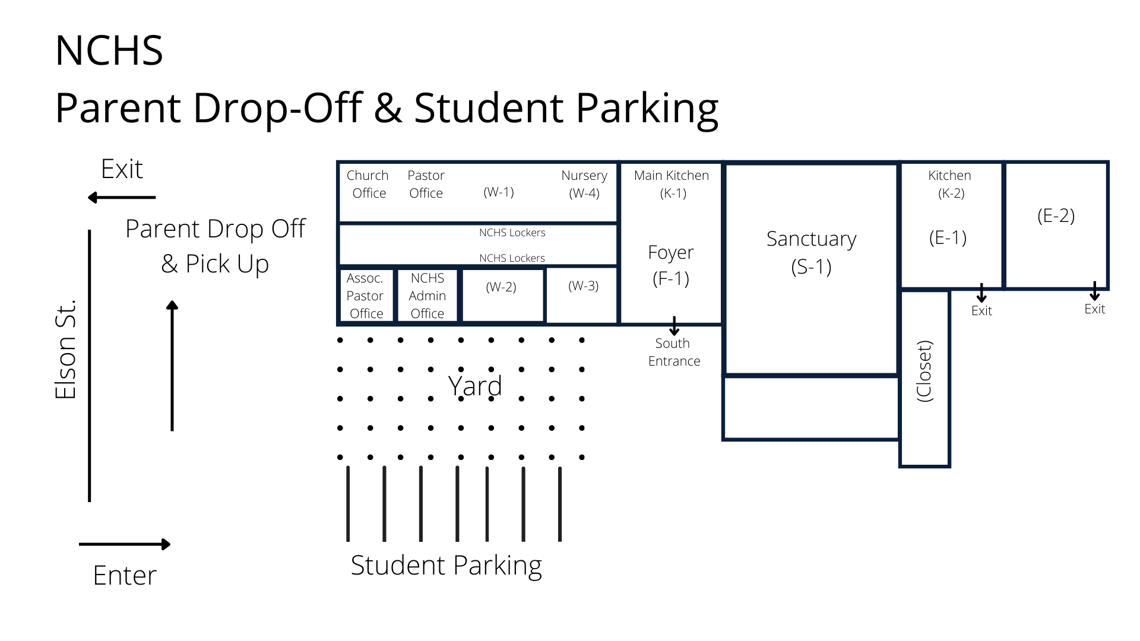

**■ Tornado & Fire Drill Map**

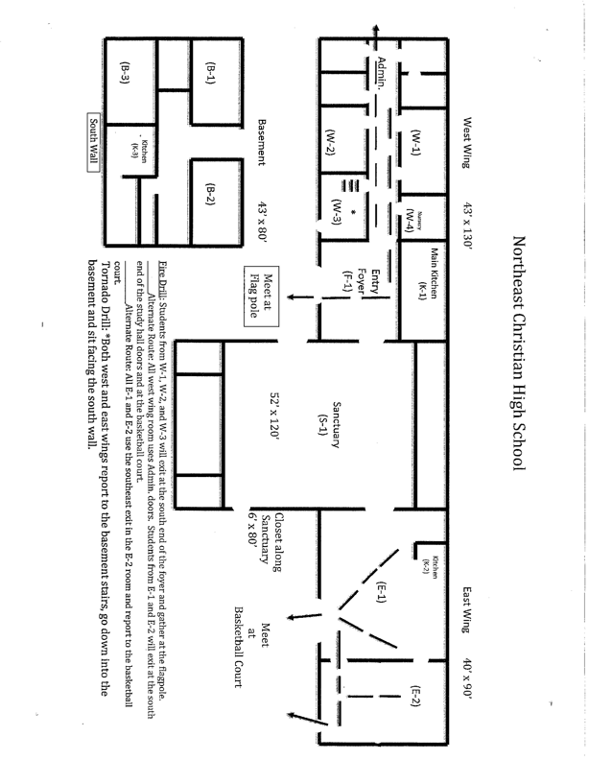

**■ Funding Philosophy**

The following philosophy statement has been adopted by the Northeast Christian High School board as the guiding principle for all fundraising activities associated with the school system.

**We acknowledge that:**

* God is forever faithful and has made a loving covenant with His people
* He desires for parents to educate their children in His ways
* We can accomplish nothing apart from God
* All provision comes from God’s hand

**We believe that:**

* Christian education is a privilege given by God through our free society
* Parents, administrators, teachers, board members and students are called to be wise and appreciative stewards of all the blessings God gives
* There are costs associated with operating a Christian school

**NCHS will approach the area of giving with the following precepts based on   
1 Chronicles 29 & 2 Corinthians 9:**

* NCHS desires first to seek God and follow His leading in all areas
* We wish to share the vision for Christian education with those already involved and with those not yet associated with NCHS
* We believe the best way to fund the system is to invite people to join God in His work by giving in the ways He leads them to give
* The result of obedience to God in this area will be joyful giving
* Above all else, we want God to receive glory in all that we do

 It is also our desire to relieve time burdens on our families. We believe that families function best when there is time to focus on God and minister to one another without excessive demands of outside events.

**■ Enrollment Process**

Parents should thoroughly read the Admissions information.

Complete enrollment application, submit required documents, and fees.

* Student’s Written Testimony
* Immunization Records
* Copy of Birth Certificate
* Copy of previous school records or a signed release form for these records.
* Enrollment Fee if applicable

A Family Reference form will be emailed to the Pastor, requesting they be returned within 7 days. These forms will be sent directly to the school once they have been completed.

When all the necessary documents and fees have been received, parents will be contacted to schedule a family interview with the principal.

At the interview, the following information will be discussed:

* School policies, procedures, and guidelines
* Enrollment Forms
* Personal Testimony
* Vision of the School

With business office:

* Collection of Fees
* Sycamore logins
* Tuition payment setup/assistance application

**■ 2024-2025 Calendar**

| 28-29 Staff In-Service | | **AUGUST ‘24** | | | | | | | | --- | --- | --- | --- | --- | --- | --- | | **S** | **M** | **T** | **W** | **Th** | **F** | **S** | |  |  |  |  | 1 | 2 | 3 | | 4 | 5 | 6 | 7 | 8 | 9 | 10 | | 11 | 12 | 13 | 14 | 15 | 16 | 17 | | 18 | 19 | 20 | 21 | 22 | 23 | 24 | | 25 | 26 | 27 | 28 | 29 | 30 | 31 | |  | | **JANUARY ‘25** | | | | | | | | --- | --- | --- | --- | --- | --- | --- | | **S** | **M** | **T** | **W** | **Th** | **F** | **S** | |  |  |  | 1 | 2 | 3 | 4 | | 5 | 6 | 7 | 8 | 9 | 10 | 11 | | 12 | 13 | 14 | 15 | 16 | 17 | 18 | | 19 | 20 | 21 | 22 | 23 | 24 | 25 | | 26 | 27 | 28 | 29 | 30 | 31 |  | | 1-3 Christmas Break School  Closed  6 Classes resume  10 No School/Office open  17 Service Day  20 MLK Day/No School  24 No School/Office open  31 Service Day |
| --- | --- | --- | --- | --- | --- | --- | --- | --- | --- | --- | --- | --- | --- | --- | --- | --- | --- | --- | --- | --- | --- | --- | --- | --- | --- | --- | --- | --- | --- | --- | --- | --- | --- | --- | --- | --- | --- | --- | --- | --- | --- | --- | --- | --- | --- | --- | --- | --- | --- | --- | --- | --- | --- | --- | --- | --- | --- | --- | --- | --- | --- | --- | --- | --- | --- | --- | --- | --- | --- | --- | --- | --- | --- | --- | --- | --- | --- | --- | --- | --- | --- | --- | --- | --- | --- | --- | --- | --- | --- | --- | --- | --- | --- | --- | --- | --- | --- | --- | --- | --- | --- | --- |
| 2 [Labor Day](http://www.calendarlabs.com/holidays/us/labor-day.php) (No School)  3 First Day of School  6 Service Day  13 No School/Office open  20 Service Day  27 No school/Office open | | **SEPTEMBER ‘24** | | | | | | | | --- | --- | --- | --- | --- | --- | --- | | **S** | **M** | **T** | **W** | **Th** | **F** | **S** | | 1 | 2 | 3 | 4 | 5 | 6 | 7 | | 8 | 9 | 10 | 11 | 12 | 13 | 14 | | 15 | 16 | 17 | 18 | 19 | 20 | 21 | | 22 | 23 | 24 | 25 | 26 | 27 | 28 | | 29 | 30 |  |  |  |  |  | |  | | **FEBRUARY ‘25** | | | | | | | | --- | --- | --- | --- | --- | --- | --- | | **S** | **M** | **T** | **W** | **Th** | **F** | **S** | |  |  |  |  |  |  | 1 | | 2 | 3 | 4 | 5 | 6 | 7 | 8 | | 9 | 10 | 11 | 12 | 13 | 14 | 15 | | 16 | 17 | 18 | 19 | 20 | 21 | 22 | | 23 | 24 | 25 | 26 | 27 | 28 |  | | **3 Re-Enrollment**  7Staff In-Service Day  14 Service Day  17 [Presidents’ Day](http://www.calendarlabs.com/holidays/us/presidents-day.php)  School Closed  21 No School/Office open  24 Open Enrollment  28 Service Day |
| **3 BBQ Blast Event**  4 No school/office open  11 Service Day  14 [Columbus Day](http://www.calendarlabs.com/holidays/us/columbus-day.php)  (No School)  18 No School/Office Open  24 End of 1st Quarter  25 Service Day  **31 Full Day** | | **OCTOBER ‘24** | | | | | | | | --- | --- | --- | --- | --- | --- | --- | | **S** | **M** | **T** | **W** | **Th** | **F** | **S** | |  |  | 1 | 2 | 3 | 4 | 5 | | 6 | 7 | 8 | 9 | 10 | 11 | 12 | | 13 | 14 | 15 | 16 | 17 | 18 | 19 | | 20 | 21 | 22 | 23 | 24 | 25 | 26 | | 27 | 28 | 29 | 30 | 31 |  |  | |  | | **MARCH ‘25** | | | | | | | | --- | --- | --- | --- | --- | --- | --- | | **S** | **M** | **T** | **W** | **Th** | **F** | **S** | |  |  |  |  |  |  | 1 | | 2 | 3 | 4 | 5 | 6 | 7 | 8 | | 9 | 10 | 11 | 12 | 13 | 14 | 15 | | 16 | 17 | 18 | 19 | 20 | 21 | 22 | | 23 | 24 | 25 | 26 | 27 | 28 | 29 | | 30 | 31 |  |  |  |  |  | | 6 End of 3rd Quarter  7 Staff In-Service Day  10-14 Spring Break  School Closed  17 Start of 4th Quarter  21 Service Day  28 No School/Office open |
| 1 Staff In-Service Day  7 Parent/Teacher Conf.  (Half Day)  8 Service Day  15 No School/Office Open  22 Service Day  27-29 [Thanksgiving](http://www.calendarlabs.com/holidays/us/thanksgiving-day.php) Break **-**  School closed | | **NOVEMBER ‘24** | | | | | | | | --- | --- | --- | --- | --- | --- | --- | | **S** | **M** | **T** | **W** | **Th** | **F** | **S** | |  |  |  |  |  | 1 | 2 | | 3 | 4 | 5 | 6 | 7 | 8 | 9 | | 10 | 11 | 12 | 13 | 14 | 15 | 16 | | 17 | 18 | 19 | 20 | 21 | 22 | 23 | | 24 | 25 | 26 | 27 | 28 | 29 | 30 | |  | | **APRIL ‘25** | | | | | | | | --- | --- | --- | --- | --- | --- | --- | | **S** | **M** | **T** | **W** | **Th** | **F** | **S** | |  |  | 1 | 2 | 3 | 4 | 5 | | 6 | 7 | 8 | 9 | 10 | 11 | 12 | | 13 | 14 | 15 | 16 | 17 | 18 | 19 | | 20 | 21 | 22 | 23 | 24 | 25 | 26 | | 27 | 28 | 29 | 30 |  |  |  | | 4 Staff In-Service Day  11 Service Day  18 **Good Friday** - no school  20 **Easter Sunday**  21 **Easter Monday** - no school  25 Service Day |
| 6 No class/Office open  13 Service Day: Blood Drive  19 End of 2nd Quarter  20 No class/Office open  23-31 [**Christmas**](http://www.calendarlabs.com/holidays/us/christmas.php) **Break**  **School closed** | | **DECEMBER ‘24** | | | | | | | | --- | --- | --- | --- | --- | --- | --- | | **S** | **M** | **T** | **W** | **Th** | **F** | **S** | | 1 | 2 | 3 | 4 | 5 | 6 | 7 | | 8 | 9 | 10 | 11 | 12 | 13 | 14 | | 15 | 16 | 17 | 18 | 19 | 20 | 21 | | 22 | 23 | 24 | 25 | 26 | 27 | 28 | | 29 | 30 | 31 |  |  |  |  | |  | | **MAY ‘25** | | | | | | | | --- | --- | --- | --- | --- | --- | --- | | **S** | **M** | **T** | **W** | **Th** | **F** | **S** | |  |  |  |  | 1 | 2 | 3 | | 4 | 5 | 6 | 7 | 8 | 9 | 10 | | 11 | 12 | 13 | 14 | 15 | 16 | 17 | | 18 | 19 | 20 | 21 | 22 | 23 | 24 | | 25 | 26 | 27 | 28 | 29 | 30 | 31 | | 2 No School/Office Open  3 Graduation  **5-9 Staff Appreciation Week**  9 Service Day  12-14 Finals Week  15 Last Day of School |

|  | No Classes/Office open |  |  | No Classes/Office closed |  |  | First/Last Day of Quarter |
| --- | --- | --- | --- | --- | --- | --- | --- |
|  | Teacher Work Day (No School for Students) |  |  | Service Day/For Him Friday |  |  | Special Days to Note |

**■ 2024-2025 Tuition and Fees**

| **Grade Level** | **Tuition** | **Enrollment**  **Fee\*** |
| --- | --- | --- |
| 9th-12th Grades | $4,500 per year  $650 per class  (students enrolled in less than 5 courses  *set by the board 8-19-24)* | $400/child |

*\*All enrollment fees are due at the time of enrollment and are non-refundable unless enrollment is contingent upon tuition assistance.*

*\*Tuition is set by the Board of Northeast Christian High School at the beginning of each calendar year.*

**■ Acknowledgement of Receipt**

**Receipt of Student Handbook, internet, computer usage, cell phone, plagiarism, and academic cheating policy**

**2024-2026** This is to acknowledge that my parents and I received and agree to the following student handbook, internet, computer usage, cell phone, plagiarism, and academic cheating policy as outlined below.

The school day is intended for spiritual and academic growth. To minimize distractions the use of cell phones, ipods, mp3’s, handheld gaming consoles, and apple/smartwatches, and other such electronic devices are prohibited on school property between 7:30 am and 3:39 pm. Cell phones are to be left in the administrator’s office at the beginning of the day and picked up at the end of the day by the students. Cell phones or other devices brought to class will be confiscated by the teacher and returned to the parents at the end of the day. Use of a cell phone, not authorized by a faculty or staff member during school hours is considered a willful defiance of authority, a disruption to the learning process and will result in the following disciplinary action.

**Consequences to be determined by the administrator.**

Plagiarism means any act of using, without acknowledgment, the ideas, writings, or inventions of another, either word for word or in substance, and representing them as one’s own. For example: failure to use quotation marks, footnotes, or bibliography to indicate material used directly or substantially from other sources in written or oral reports. This definition would also apply to themes, poems, musical compositions, research reports, reviews, etc. or to any other work done in preparation for school assignments.

Penalty: Students will receive a grade penalty and/or disciplinary action.

1st offense Private conference with student and teacher.

2nd offense Parents contacted

3rd offense If repetitive, students may receive an In-school / out-of-school suspension.

**■ 2024-2025 Parent/Student Handbook Agreement**

We (Northeast Christian High School Parents/Guardians) have read the NCHS Parent/Student Handbook for the 2024-25 school year. We understand the guidelines and agree to comply with them.

We also understand that the handbook can be found in the school office, as well as online. We will contact the school office at 660.342.1100 if we would like a paper copy.

_________________________________________________________

Parent Printed Name

_________________________________________________________ __________________

Parent Signature Date

This year NCHS will be piloting and implementing a Positive Behavior System (P.B.S.) as part of the schoolwide disciple program. I understand that this program is subject to change as the year progresses. I agree that this program is new to NCHS and give my support for NCHS to implement the program.

________________________________________________________

Parent Printed name

________________________________________________________ __________________

Parent Signature Date

I (Northeast Christian High School Student) have read the NCHS Parent/Student Handbook for the 2023-24 school year. I understand the guidelines and agree to comply with them.

I also understand that the handbook can be found in the school office, as well as online. I will contact the school office at 660.342.1100 if I would like a paper copy.

_________________________________________________________

Student Printed Name

_________________________________________________________ __________________

Student Signature Date